**Bonneville Cutthroat Trout Habitat Improvement in the Little Bear River**

Utah State University, College of Engineering

4100 Old Main Hill Logan, UT 84322

Prepared by:

Patrick Archibald

Kyle Miller

Utah State University

December 9th, 2024

Table of Contents

Table of Contents 2

Abstract 3

Introduction 3

Background 3

Prior Work on the Little Bear River Ecosystem and Water Management 5

Objectives 6

Model Formulation 7

Model Results and Recommendations 8

Conclusion 9

References 11

Appendix A 12

Abstract

The Bonneville Cutthroat Trout Habitat Improvement in the Little Bear River Project aims to model strategies to enhance Bonneville Cutthroat Trout (BCT) populations and habitat in Utah’s Little Bear River. This project examines the impact of Porcupine Reservoir releases on water levels at the confluence of the South and East Forks of the Little Bear River. The confluence of these two portions of the river has historically been dry due to irrigation diversions. Building on extensive studies of the river's physical, chemical, and biological dynamics, this project explores how human activities, particularly urban and agricultural, alter riverine areas and affect fish ecology. Using data from prior studies, the model will focus on optimal water release schedules and volumes from Porcupine Reservoir to increase in-stream flow in the East Fork just before the East and South Fork confluence. The model formulation includes key decision variables and constraints—such as inflows, reservoir capacity, and irrigation needs—and aims to maximize suitable habitat for BCT. Ultimately, this model seeks to provide actionable insights for reservoir managers and shareholders, balancing ecosystem health with agricultural demands, and promoting long-term sustainability for BCT in the Little Bear River.

Introduction

Our project models ways to improve Bonneville Cutthroat Trout (BCT) populations and habitat within the Little Bear River from Porcupine Reservoir to Hyrum Reservoir. This project analyzes how reservoir releases and irrigation diversions affect the riverine habitat between the outlet of Porcupine Reservoir and the confluence of the East and South Fork of the river near Avon, Utah. Irrigation diversions are present just below the reservoir, reducing the volume of water continuing to flow to the East and South Fork confluence. This project also analyzes the tradeoffs between irrigation benefits and instream flow requirements to increase BCT habitat.

Although Porcupine Reservoir is a privately owned and operated reservoir, a portion of the water stored is owned by the Utah Division of Wildlife Resources (UDWR). The UDWR has an allotment of 1,500 acre-feet of water in the reservoir. However, only 500 ac-ft is available for release and the remaining 1,000 ac-ft is inaccessible for release. Despite owning this substantial volume of water, the UDWR has not used these reserves in the past. This project will also explore how potential releases from the UDWR’s active pool could maintain connectivity between the East Fork’s final irrigation diversion and the confluence with the South Fork.

A Generic Algebraic Modeling System (GAMS) was created to model the use of Porcupine Reservoir releases to improve water levels in the East Fork just before the East and South Fork confluence, and to analyze the benefit tradeoffs between irrigation use and instream flows.

Background

Porcupine Reservoir is an essential water resource in Cache Valley. The reservoir was constructed in 1964 by damming the East Fork of the Little Bear River. The reservoir has a maximum capacity of 13,196 ac-ft, with 11,650 ac-ft available as active storage. The reservoir is under the management and ownership of the Porcupine Reservoir Company. The reservoir is primarily used for downstream irrigation but is also a recreational area within the Uinta-Wasatch-Cache National Forest. The Porcupine Highline Canal Company and Paradise Irrigation and Reservoir Company are the primary diverters from the East Fork of the Little Bear River.

Flow within the East Fork of the Little Bear River is completely reliant on releases from Porcupine Reservoir. Figures 1 and 2 illustrate the East Fork of the Little Bear River and its confluence with the South Fork. The Little Bear River is an essential habitat for Bonneville Cutthroat Trout especially in the East Fork region due to the water’s colder temperatures. The river plays a vital role in agricultural lands, residential water use, and natural ecosystems. Currently, there is a portion of the East Fork upstream of the confluence with the South Fork that sees very low water levels and occasionally is completely dry due to irrigation diversions before the confluence of the East and South Forks. This loss in riverine habitat negatively affects fish ecology.

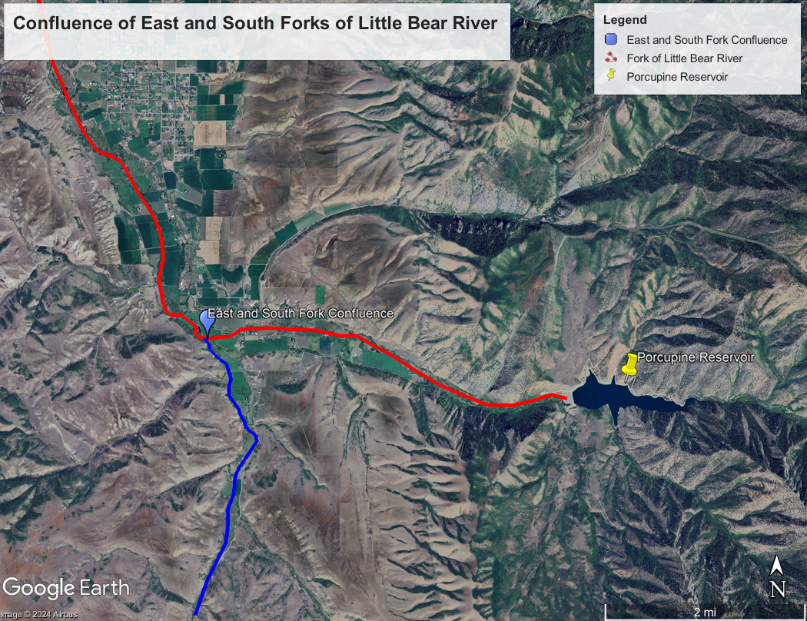

Figure 1

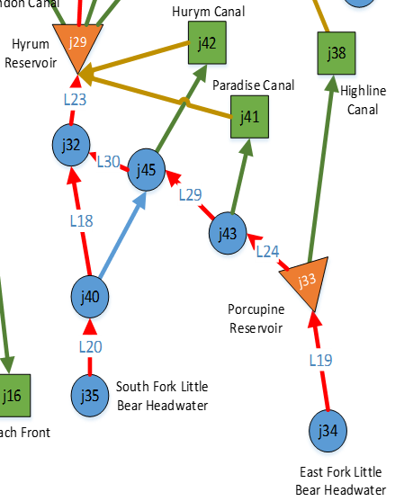

Figure 2

Prior Work on the Little Bear River Ecosystem and Water Management

A fair amount of research has been done on the Little Bear River and its fish populations. Researchers have found that agriculture and urban development and other human actions are impacting the Little Bear River. Many of the studies focus on the impacts of temperature levels and temperature variation in the water on Bonneville Cutthroat Trout. Another study analyzed how releases from the reservoirs during different times of the year affected habitat for fish and other aquatic species.

Wayne A. Wurtsbaugh, et al. [7] published their work in 2013. Their study found that agricultural and urban development in the area surrounding the Little Bear River was having an impact on the physical and biological characteristics of the river. They collected data on the distribution of fish species in the river and observed that the native species, BCT, was rare. Another study performed by Christian Smith in 2012 [6] through Utah State University analyzed the impacts of human activities on the Little Bear River. Their study primarily focused on reaches of the river above and below Hyrum Dam, illustrating the barrier that Hyrum Dam imposes on fish passage. Their study included capturing fish, as well as studying samples of pebbles and aggregates in the riverbed.

Other human actions that are resulting in negative consequences to the Little Bear River’s habitat are wastewater discharge and agricultural runoff. Jared Baker [3] investigated the chemistry of the water in the Little Bear River and found that these human activities were the greatest contributors to improper nutrient levels and algal growth in the river. Nitrogen and phosphorus were identified as the limiting components of algae growth. If water managers understand this, they can adjust their practices to minimize impacts to the river.

Temperature variation has been well studied in both the Little Bear River and the Logan River. Bundy et al. (2012) [4] researched the impacts of temperature variation on the BCT population in the Logan River. Even though the research was on a different river, the BCT is native to the Logan River and the Little Bear River. Bundy and their team found that almost all aspects of BCT spawning, such as magnitude, duration, and frequency, were all controlled by river hydrology. They observed direct responses in spawning from temperature fluctuations.

Specifically on the Little Bear River, Andy Pappas [5] researched temperature in 2013. They found that discharge and temperature increased with decreasing elevation to Hyrum Reservoir. The largest increases in temperature occurred just below the reservoirs in the system. They found a relationship between flow levels and water temperature and determined that diversions along the Little Bear River cause unnatural characteristics within the river.

Ayman and Rosenberg [2] created a model for their 2017 research paper that investigated the impacts of different releases from the reservoirs on the Little Bear River on aquatic and wetland habitats. They found that releases during the wintertime, generally speaking from December to March, were especially important for habitat creation and preservation. These wintertime releases also open space in the reservoir to capture spring runoff, reducing spill or other higher releases in the springtime which could kill fish eggs or fry.

Objectives

The goal of our project is to build upon the work and research that has already been done, and to help water users and other people who interact with the Little Bear River system understand how their actions impact BCT habitat. By creating a modeling system for releases from Porcupine Reservoir, we aim to illustrate how user demands, reservoir operations, and wildlife habitat goals can all be met. An optimized plan for releases from the reservoir will aim to maintain connectivity between the confluence of the South and East Forks of the Little Bear River.

As the river stands now, the human impacts are devastating to the native fish population and overall river habitat. Nearly all of the water is diverted out of the East Fork before it joins the South Fork. This leaves a notable portion of the river extremely dry, eliminating any chance for fish to make their way upstream for spawning. As was found in Pappas’ research, the coldest water in the Little Bear River is found in the upstream reaches, and the dry portion above the confluence does not allow any fish passage to the uppermost reaches. Our model optimizes releases to change this dire situation and restore the river closer to its natural processes and characteristics. The model indicates which years over our model time series that connectivity can be achieved. Our hope is that users in the future can take those patterns of releases and maintain connectivity between the East Fork and the confluence in years to come.

Model Formulation

The model for the East Fork of the Little Bear River has many constraints and variables that result in a significant model formulation. The original model we created had an objective function to minimize the required costs from purchasing water rights while maintaining a minimum annual flow to the confluence. We attempted running the model with other objective functions, such as maximizing the total flow to the confluence while staying within a budget, or maximizing flow to the confluence without a budget. The model formulation discussed in this section is for minimizing costs incurred from water purchases while meeting flow constraints at the confluence.

There are four variables within the formulation. The decision variables in each timestep (year) of the model are volume stored, volume released for irrigation, volume of purchased water released, and volume released from UDWR allocation. These variables are represented by , , , and , respectively. Each year within the model there is a reservoir mass balance equation that uses these variables. The equation is:

Our team decided that a reasonable amount of water to maintain flow to the confluence is approximately 3 cfs. This equates to 6 acre-feet per day, or 2,190 acre-feet annually. The flow to the confluence is constrained to be greater than or equal to 2,190 acre-feet. The equation that defines this flow is written with an additional variable and is expressed:

The model assumes that the water released from the UDWR does not have any cost associated with it and that the UDWR has chosen to start using their water right to improve the habitat in the Little Bear River. The water purchased has an associated price. We developed this price using date from the Cache Valley Water Bank Model (Akbar 2024) [1]. The crop we selected to base the model on is alfalfa, as this is the most common crop in the area. The water bank model indicates that every acre of alfalfa requires 2.012 acre-feet of water annually. This means that each one acre-foot of water can irrigate 0.497 acres of alfalfa. The model also indicates that every acre of alfalfa produces a net return of $68.29. Multiplying the 0.497 acres of alfalfa produced with the net return shows that the value of one acre-foot of water is $33.94. This price is what is used to create the objective function:

Additional constraints on the model include:

The constraint on UDWR releases is due to the nature of the water right that UDWR holds. Only 500 acre-feet of their 1,500 acre-foot water right is accessible for release. The general storage constraint as well as the final storage constraint are due to the physical capacity and characteristics of Porcupine Reservoir. The overall storage and threshold (minimum) storage are both defined in the Cache Valley Water Bank Model (Akbar 2024) [1].

Model Results and Recommendations

After the model was simulated dozens of times in GAMS along with rigorous analysis of decision variables, constraints, and possible objective functions, the model reported that the scenario would be infeasible. This result may be caused by improper model formulation, however, the infeasibility of reservoir operation for optimizing flow to the East and South Fork confluence is a possible scenario. Because the Porcupine Highline Canal Company and Paradise Irrigation and Reservoir Company have been appropriated nearly all volumes released from the reservoir and considering the reservoir’s inflows, capacity, and threshold volume, managing allocation to instream flows may prove infeasible.

Seeing that the model resulted is an infeasible solution, we decided to take an analytical approach through Excel to discover how to optimize instream flow through the East Fork of the Little Bear River. Each year, both primary irrigation companies using reservoir releases are allocated a specific water right. The Porcupine Highline Canal Company has access to 6,300 acre-feet of water each year. The Paradise Irrigation and Reservoir Company has access to 5,524.71 acre-feet. However, due to varying agricultural needs and yearly precipitation patterns, the volume of water diverted by these irrigation companies may be less or more than their water right.

To optimize water flow and thus BCT habitat in the East Fork leading to the confluence, Utah Division of Natural Resources (UDNR) and UDWR could purchase the rights to unused water rights of the primary irrigation companies. This tradeoff would compensate the irrigation companies financially and promote the natural ecosystem of BCT in the Little Bear River.

As described in the model formulation, the cost per acre-foot of water is equivalent to $33.94. Based on this unit price, the consumptive use of irrigation companies from 2010 to 2022, and the available water rights, an analysis of irrigation benefits and instream flow retention was completed. Appendix A shows the table detailing the analysis.

The first step was determining the total water right from the irrigation companies. This data was included in the Cache Valley Water Bank Model. The amount diverted by each irrigation company from 2010 to 2022 was included in the Cache Valley Water Bank Model (Akbar 2024)[1]. Both of these sets of data were used to create the table in Appendix A. The difference between the total water right and the actual amount diverted is the total water available for potential instream flow. The total compensation to the irrigation companies to purchase this volume was then calculated based on the unit price. As shown in the table, the tradeoff cost varies from $2,930.38 to $215,763.03. The UDWR would presumably work within a specific budget for purchasing the rights to these diversions. However, based on the yearly instream flow goal, the UDNR/UDWR may or may not have to purchase all available water.

The yearly instream flow goal from the East Fork to the confluence is 2,190 acre-feet. It is assumed that the UDWR would begin to send their entire 500 ac-ft supply each year downstream to increase BCT habitat in the East Fork of the Little Bear River. This constant discharge leaves the yearly amount of 1,690 acre-feet needed to be acquired from the irrigation companies.

The previously mentioned analysis revealed in which years this would be a feasible solution based on the total water available for potential instream flow. In years 2010, 2011, 2014, 2015, 2017, 2021, and 2022 the yearly instream flow goal could be met with use of unused irrigation water rights. It is recommended that UDNR/UDWR purchase the needed water rights to meet the yearly instream flow goal in years when total water available for potential instream flow is sufficient. The annual cost of this purchase is detailed in Table 1 in Appendix A. This approach to water management would financially benefit irrigation companies, restore the BCT habitat in the East Fork of the Little Bear River, and increase connectivity between upstream and downstream portions of the Little Bear River.

Conclusion

While the GAMS model created to optimize flow to the confluence of the East and South Forks of the Little Bear River was found to be infeasible, this does not mean that habitat restoration and preservation in the Little Bear River for BCT is impossible. In the years that the model covered from 2010-2022, not every year has enough water to meet all the constraints and demands within the system while also allowing connectivity to the confluence. The insights gathered from the analysis of water use over that period provides valuable information for water managers to consider in future years.

Each year that the water users take less than their entire allotment, the UDWR/UDNR could forecast how to purchase the un-used rights and release those volumes during seasons when connectivity would be especially beneficial to the BCT population such as spawning. As explained in the Model Results and Recommendations section, the cost for this water purchase could be anywhere from roughly $2,000 to $215,000. While this is a very wide range of costs, there are other ways to use these funds to benefit BCT.

One example of a potential strategy for the agency in future years could be to continuously budget for the largest possible expense (~$215,000) based on this historical data. In years where $215,000 of water rights are available to purchase, then they can purchase them and release from the dam to maintain flow to the confluence. In years where the irrigation companies use more of their water right and do not have as much to sell, the UDWR/UDNR would have a surplus budget. However, in these years, that extra budget can be used for other conservation projects in the Little Bear River such as stream restoration or shaping, debris and undergrowth removal, or other relevant projects to prepare the river for when suitable flows return.

In conclusion, there are resources for water managers and government agencies to promote conservation and preservation of the native BCT population in the Little Bear River. While the limits of the reservoir, watershed, and water demand have not allowed for connectivity between the East and South Forks of the river in the past, there are options in the future for ways to restore flow to the confluence of the forks. Available data shows that through exchange/purchase of unused water rights, other users besides irrigation companies have the capacity to use those water rights to directly benefit the BCT population.

References

1. Akbar, H., D. E. Rosenberg (2024). Collaborative Model for Water Bank in Cache Valley, UT, HydroShare, http://www.hydroshare.org/resource/c9614e389e324b7ba92d5c33247504a1
2. Ayman H. Alafifi, David E. Rosenberg. (2020). Systems modeling to improve river, riparian, and wetland habitat quality and area. *Environmental Modelling & Software (Volume 126).* <https://www.sciencedirect.com/science/article/pii/S1364815218305309>
3. Baker, Jared (2013) "Algal Nutrient Limitation throughout the Little Bear River Watershed," Natural Resources and Environmental Issues: Vol. 18 , Article 7. Available at: <https://digitalcommons.usu.edu/nrei/vol18/iss1/7>
4. Budy, Phaedra.; Seidel, Sarah.; Koons, David.; Roper, Brett (2012) “A Study of the Spawning Ecology and Early Life-History Survival of Bonneville Cutthroat Trout” <https://digitalcommons.usu.edu/cgi/viewcontent.cgi?referer=&httpsredir=1&article=1394&context=wats_facpub>
5. Pappas, Andy (2013) "Temperature and Discharge on a Highly Altered Stream in Utah's Cache Valley," Natural Resources and Environmental Issues: Vol. 18 , Article 4. Available at: <https://digitalcommons.usu.edu/nrei/vol18/iss1/4>
6. Smith, Christian (2013) "A Fisheries Investigation of the Previously Un-Surveyed Little Bear River," Natural Resources and Environmental Issues: Vol. 18 , Article 10. Available at: <https://digitalcommons.usu.edu/nrei/vol18/iss1/10>
7. Wurtsbaugh, Wayne A.; Heredia, Nick; Palacios, Patsy; Baker, Jared; Broderius, Chance; Fisher, Katie; Fuller, Jason; Pappas, G. Andrew; Smith, Christian; and Weston, Marc (2013) "A River Continuum Analysis of an Anthropogenically-Impacted System: The Little Bear River, Utah," Natural Resources and Environmental Issues: Vol. 18 , Article 1. Available at: <https://digitalcommons.usu.edu/nrei/vol18/iss1/1>

Appendix A

Link to GitHub Repository that contains GAMS Code, Excel File, and Final Report

<https://github.com/khmiller854/Miller>

